Statements 2026 – IOIA Board of Directors Candidates

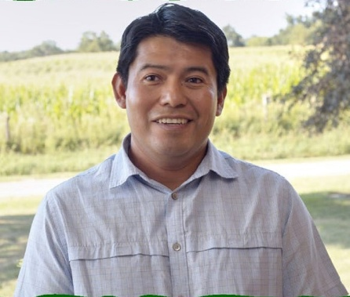
Margarito Cal, Hawai’i, USA
Greetings IOIA Members!
My name is Margarito Cal, and I am happy to present myself as a candidate for the IOIA Board. I come from an agricultural background, as I was born in a Mayan village in Southern Belize. I have grown diverse food crops in Belize, California, Illinois and Hawai’i.
I am currently a full-time reviewer for MOSA and have 10 years of experience as a full-time inspector for 7 organic certifiers, plus other identity preserved standards/certifiers. Due to moving and logistical challenges, I did not complete any inspections in 2025 but have completed over 3,500 crop, livestock and handler inspections. I currently am serving as board liaison to IOIA's Asia Pacific committee.
As an 11-year member of IOIA, I would like to commend the organization on its unwavering
commitment and integrity in delivering decades of gold standard inspector training. Over the next year, I would like to see improved collaboration with the ACA and NOP in supporting IOIA and IOIA trained inspectors.
Over the next 5 years, I would like to see IOIA trained members, both within and outside the US, be recognized and supported as valuable stakeholders in protecting organic integrity. I continue to believe that the inspector community’s experiences with organic operators are valuable key indicators regarding the effectiveness of current regulations and best practices.
Thank you for your consideration.

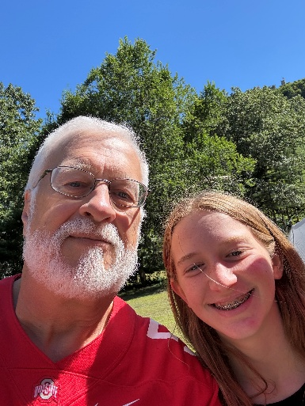
Mark Novak, Massachusetts, USA
I’m Mark Novak and I live in Deerfield, MA with my wife of 51 years; I am father of four and grandfather of eleven. Most of my career has been devoted to the needs of natural and organic food consumers. My work has been in a variety of supply chain and general management roles across distribution, production and marketing of natural foods. Over the past four years that work has transitioned into independent organic handler systems inspector working with multiple certifiers. In 2025 I submitted just over 200 handler inspections.
IOIA training in 2014 and occasionally since, added a structured perspective to my operational experience. Having a couple years as full time inspector, I see IOIA providing professionally sound ongoing training as both a current and long-term priority. As an independent organization, IOIA is a connecting point for us as individual professionals and with the larger trade. In fulfilling that purpose, IOIA communicates our gained experience with certifiers and accrediting bodies. In that way, it represents our interests. Looking forward, changes in the structure and administration of certification systems seem likely. Not every certifying body will respond to technology and regulatory changes in the same way. IOIA can credibly engage and participate by ensuring training remains current with updated processes. Helping onboard well-prepared inspectors and providing ongoing training current with needs of certifiers is a wise longer-term focus.

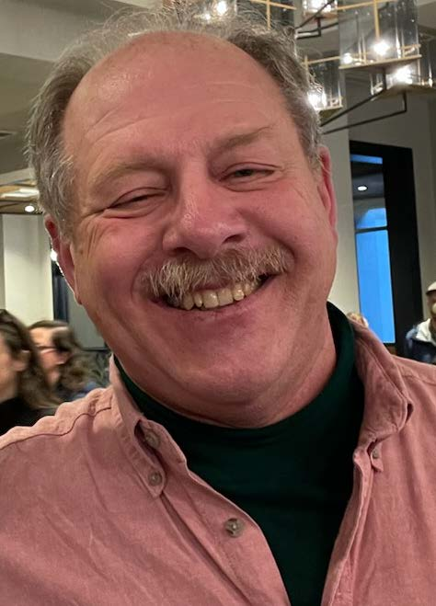
Leonard Pollara, Michigan USA
My walk with organic began at the age of 16 on our family farm in NJ. From that moment forward I continue to learn all that I can about organic farming. In my early 20s I resolved to devote energy to promoting organic agriculture. Now, 50 years later, having built my farm from 4.5 acres to 153, while serving in many roles in the organic community, I would like to bring that experience to IOIA. Other service experience notably includes president of NOFA-NJ, Sussex County Board of Agriculture, & Rutgers Board of Managers, prior to serving on the Policy & Bylaws committees of IOIA. Participating in numerous joint committees with ACA has helped me remain current with issues confronting IOIA, the organic industry and organic community.
2025 was both a challenging and a rewarding year in many ways. Continuing to complete inspections in all scopes in the US, Canada & Mexico has during which I completed 33 inspections most from August to year’s end. In addition to this, I served as a TOPP mentor and presenter. Some new challenges are emerging that will impact IOIA’s future, particularly competition in training services for inspectors, and inspector development.
I do believe that in addition to continuing the existing operations, focusing on expanding training, mentoring and membership recruitment is vital to IOIA success. Further developing mentoring opportunities, collaborations with institutions of higher education and exploring and continuing to build upon collaborative relationships that further support inspectors. It remains difficult to look forward with any clarity. And yet it seems that working on harmonizing inspection quality via developing and offering a portfolio of calibration exercises would be most useful to inspectors.
In addition to working as an inspector, I have completed numerous ACA internal reviews for NOP compliance, served as a peer evaluator and reviewer. I look forward to serving as a member of the IOIA Board and ask for your consideration and vote.

