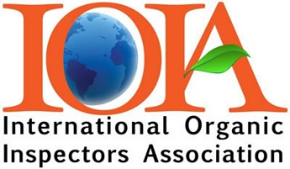

IOIA Self-Directed Learning Program
Application for Approval

Acceptance into a Self-Directed course requires pre-approval before you pay or register for the course.

Please complete the following questions and email to: ioiaonlinetraining@ioia.net

IOIA SDL staff will review your level of training and experience to determine qualifications.

Please indicate the course you are applying for:

☐100 Level COR Series – Our Organic Certification System – Regulation
☐100 Level COR Series – Organic Crop Production Standard
☐ 200 Level IOIA/American Grassfed Association Dairy Inspection Standards
☐ 200 Level Dairy Feed Audit

- Are you an IOIA Member? ☐Yes ☐ No

Name:
Email:
Telephone:

- Are you currently an Organic:

Inspector ☐ Yes ☐ No Number of years Number of inspections
Scopes
Reviewer ☐ Yes ☐ No Number of years Number of reviews
Scopes
Program manager? ☐ Yes ☐ No Number of years
Scopes
If you are applying for Grassfed or Dairy Feed Audit:
- Have you completed the Basic IOIA Livestock Inspection course? ☐ Yes ☐ No
- IOIA 100 Level Livestock Standards Webinar? ☐ Yes ☐ No
- IOIA Field Training? ☐ Yes ☐ No

If no to the previous IOIA livestock-related training questions, please explain why you feel you are qualified to take this course.

Click or tap here to enter text.

